Physics – Formal Lab Report #2

**Blake Segars with Jimmy Casey and Jake Wiltse**

This lab consisted of creating two charges set at a distance apart from each other, which then led to finding the electric field and electric potential. One we found some arbitrary values, we plugged them into the correct equations to find the fields and potential, which was then graphed in sage math cell. We sketched a rough graph by hand before attempting the lab for an end comparison. In conclusion we ended up have a very similar graph to the result of this lab.

**INTRODUCTION**

For many years these formulas have been used to find vector field and electric potential between charges. It is still used to find how to forces will react to each other, one example being a charged magnet vs another. In this lab, we practice finding the fields of two charges at arbitrary points. The server [1] <https://sagecell.sagemath.org> , helps graph vector fields and contours about an electric field.

**PROCEDURE**

To start the lab, the first information needed is two random charge numbers and where they will be located from the origin. Then draw a graph and label the axis and place the charges in the correct spot. Next draw the hypothetical contour lines around the charges along with a few vectors produced by the two charges. The next step is finding the right equations to find the experimental contour and vector plot. These will be the electric potential and the electric field equations. Once all data is input into the equations, solve for the variables. Then enter your equations into <https://sagecell.sagemath.org/> in the format given in the lab manual. This will give the final accurate representation of your vector and contour fields.

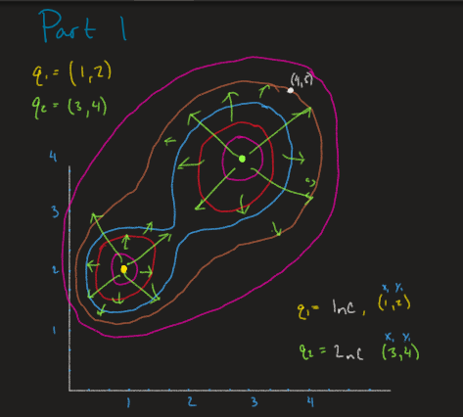

*Figure 1: shows the rough graph of the two random charges placed with the theoretical fields.*

Part 2 in the lab was a game. Click on the link given in the lab manual and the game will open. Then use positive and negative charges to push the negative charge into the goal.

**DATA**

Data

|  |  |  |
| --- | --- | --- |
|  | **Location** | **Charge** |
| **Charge 1** | ( 1 , 2 ) | +1nC |
| **Charge 2** | ( 3 , 4 ) | +2nC |

*Table 1: Arbitrary Data Chosen*

Results

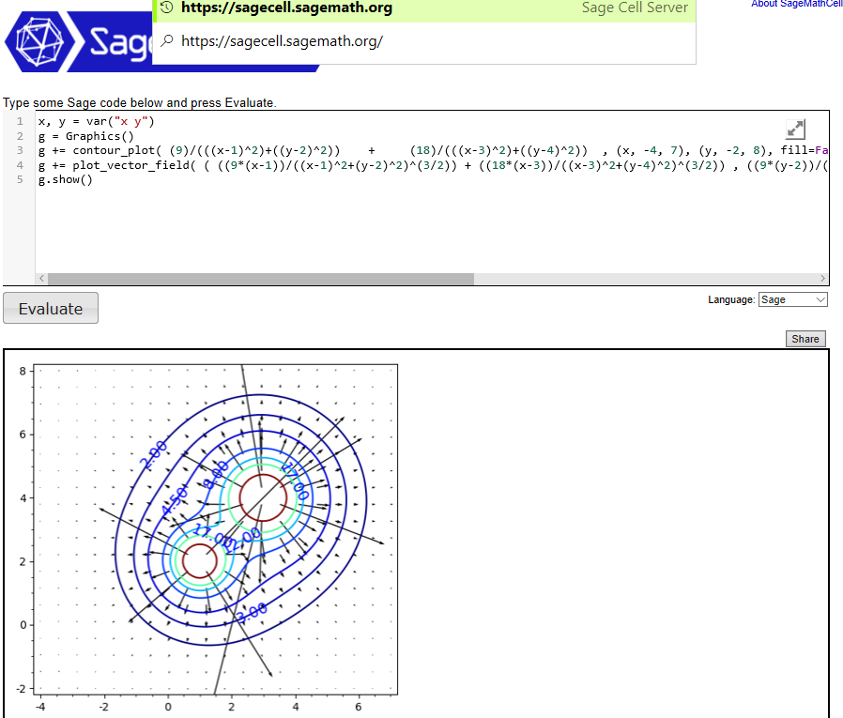

*Figure 2: The final experimental result in Sagemathcell*

Results

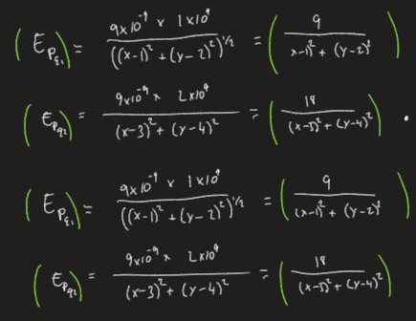

*Figure 3: The work and Final answers of the electric potential of the two charges*

Results

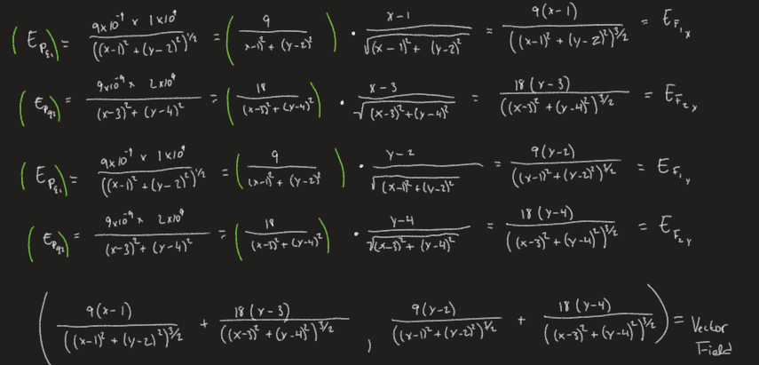

*Figure 4: This is the work and Final answer for the coordinates of the vector field*

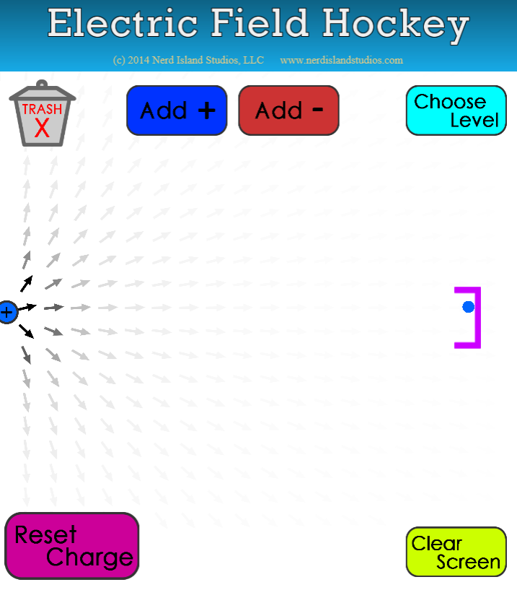

*Figure 5: Field Hockey Level 1*

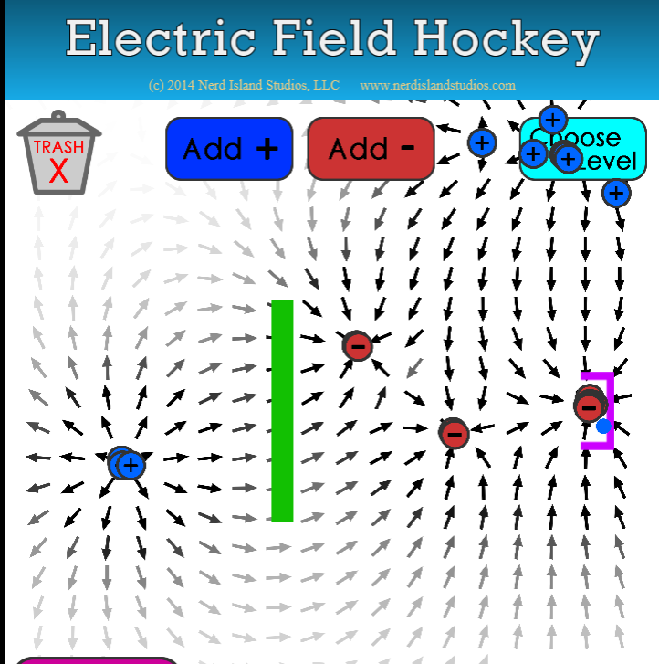

*Figure 6: Field Hockey Level 2*

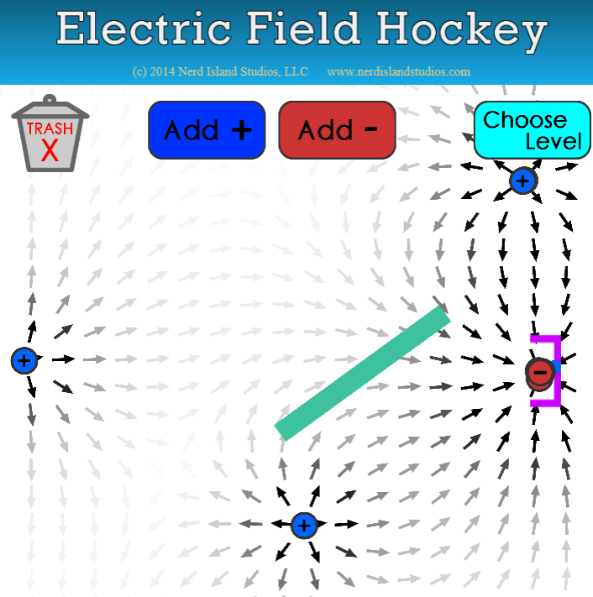

*Figure 7: Field Hockey Level 3*

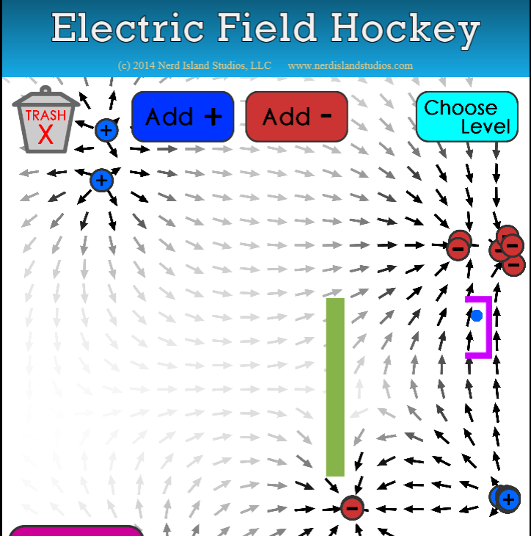

*Figure 8: Field Hockey Level 5*

**ANALYSIS**

**Formulas:**

$E= \frac{K*q}{{\left(x-x_{1}\right)}^{2}+{\left(y-y_{1}\right)}^{2}}$

$E_{VF}=E_{P} (\cos{∅, sin∅)}$

1. Cos $∅$ = $\left(\frac{x-x_{1}}{\sqrt{{\left(x-x_{1}\right)}^{2}+{\left(y-y_{1}\right)}^{2}}}\right)$
2. Sin $∅$ = $\left(\frac{y-y_{1}}{\sqrt{{\left(x-x_{1}\right)}^{2}+{\left(y-y_{1}\right)}^{2}}}\right)$
3. R = $\sqrt{x^{2}+y^{2}}$

These 5 formulas were used to find the experimental result of the fields around two charges. Formula 1 is the Electric potential, which is also the equation for the contour lines. Formula 2 is the vector field formula. Formula 3 and 4 are sin and cos formulas used to find the coordinates for the vectors. Formula 5 is just a generic distance formula.

**SUMMARY**

The most important results of this lab were the electric potential and vector field results. As no firm numerical unit was described as the answer, all formulas were used to find the equations used to graph the contour and vector lines. The hypothetical lines matched very closely to the experimental lines which matched expectations. Throughout all the calculations and equation making, there were no real mishaps with uncertainty. The only uncertainty that could happen is a rounding error with the computer or the inexact graphing by the computer. The only way this could be corrected is by a much more expensive math software along with better more precise graphics. The game for part 2 of the lab was straight forward and a real fun and nice way to try and understand a little of how charges work.

The lab was challenging and fun to figure out sage math and how to make the charged particle make the basket. This was a good lab and I have no suggestions for improvement.

**References:**

https://sagecell.sagemath.org/